
UI for DApps – Building a DApp Frontend

Objective:
Software Used:
To create and implement a responsive user interface for a Decentralized Application (DApp) that integrates with a blockchain network and enables users to interact smoothly with smart contracts
- Laptop/PC
- Node.js and npm
- Visual Studio Code (VS Code)
- React.js / HTML / CSS / JavaScript
- Web3.js or Ethers.js Library
- MetaMask Wallet

Theory/Concept:

DApp Frontend:
A DApp frontend serves as the user interface layer that enables users to interact with smart contracts deployed on a blockchain. Unlike conventional applications, DApps utilize Web3 libraries to connect the frontend to the blockchain network via wallet providers such as MetaMask.

Decentralized Frontend:
The Decentralized Frontend of the DApp enables direct interaction between the user interface and smart contracts through RPC endpoints, removing the need for centralized servers. It incorporates wallet integration features that allow users to connect their blockchain wallets, such as MetaMask, to perform transactions and access on-chain data securely. Additionally, the frontend is built with a responsive design to ensure smooth functionality and a consistent user experience across all devices, including desktops, tablets, and mobile platforms.

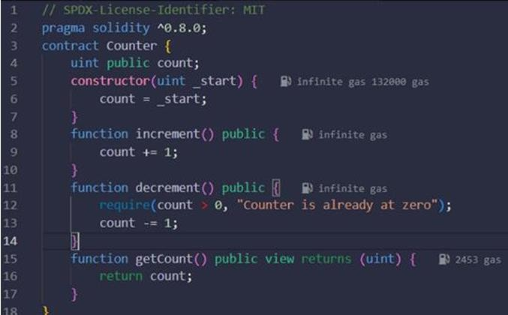
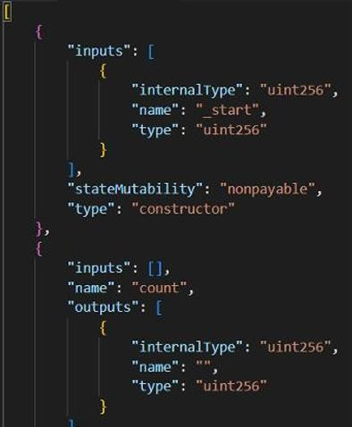
Procedure:
- Set up a React.js or HTML project folder using VS Code.
- Install required dependencies using npm:
- Npm install web3 or npm install ethers
- Create a Connect Wallet button in the frontend using JavaScript:
- Import the ABI and contract address to interact with the deployed smart contract.
- Use Web3.js or Ethers.js to read and write data to the blockchain.
- Create user interface components (buttons, forms, input fields) for blockchain actions like:
- Sending transactions
- Reading smart contract data
- Displaying balances or messages
- Connect MetaMask and ensure the wallet address appears on the frontend.
- Test DApp functionality by performing a blockchain transaction.
- Verify UI responsiveness and error handling for failed transactions.
- Ensure data updates dynamically after successful transactions.

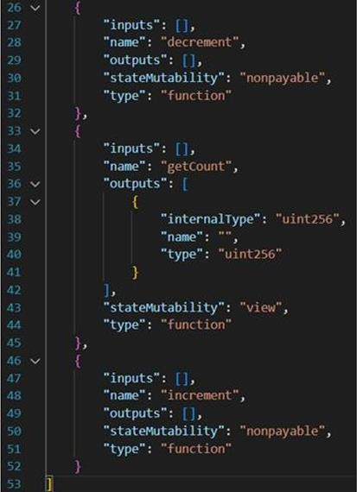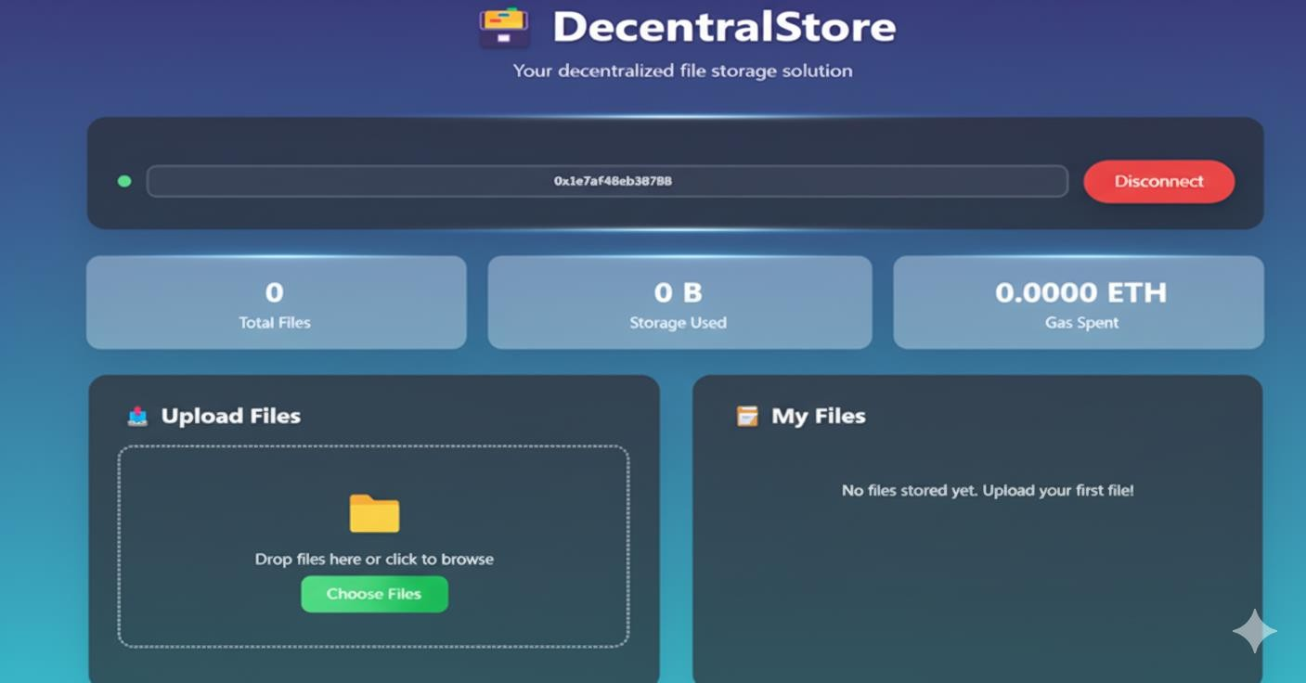

Observation :
- The DApp frontend connected successfully to the blockchain using Web3.js/Ethers.js.
- MetaMask integration allowed secure wallet connection and transaction signing.
- Smart contract data was fetched and displayed correctly on the UI.
- The interface was responsive across multiple devices.

